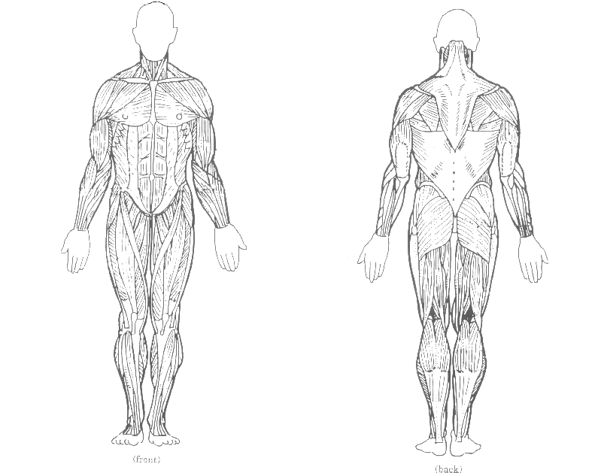
Pectorals
Abdominals
Quadriceps
Biceps

MUSCULAR SYSTEM

4th Grade Study Sheet

2 muscles used when shooting a basketball are Deltoids & Triceps

Trapezius

Deltoids

Triceps
Gluteus Maximus

Hamstrings

Gastrocnemius

