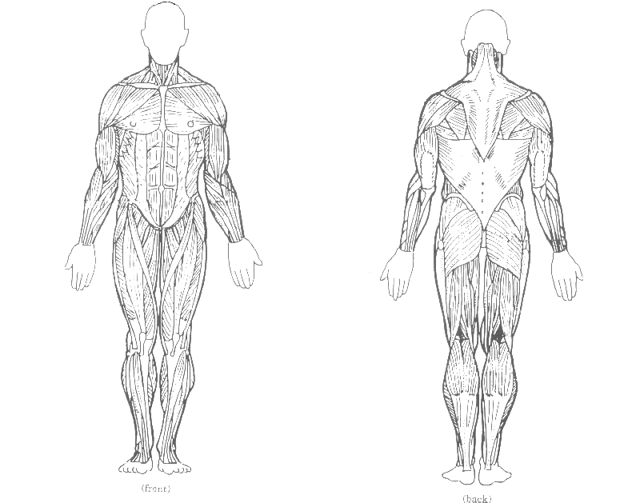
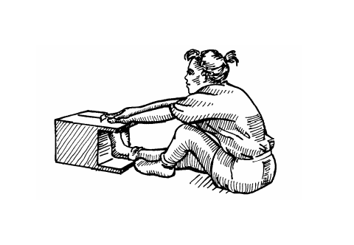
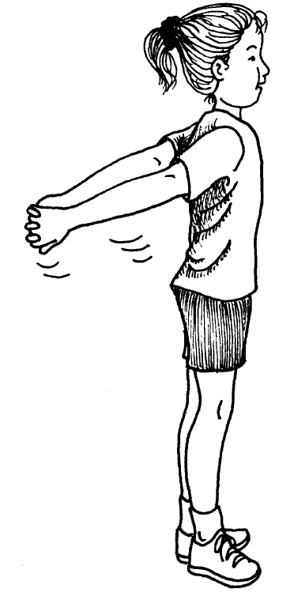
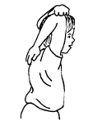
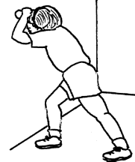
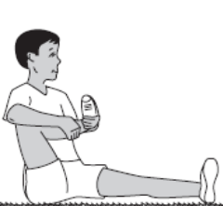
Pectorals

Abdominals
Quadriceps

Biceps
Triceps
MUSCULAR SYSTEM

3rd Grade Study Sheet

2 muscles used when running are Quadriceps & Hamstrings

Gluteus
Maximus
Hamstrings

Gastrocnemius
Pectoral
and
Biceps
Stretch
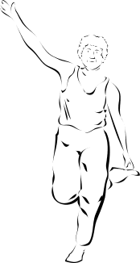

Triceps
Stretch
Hamstrings
Stretch
Gastrocnemius
Stretch
Gluteus
Maximus
Stretch

